**Dash App Interactivity Assignment**

**There is no need to submit assignments anywhere. This is for your own practice.**

**Do your best to solve these assignments before looking at the solutions. Even if you don’t solve all the exercises correctly, the process of trying is where you learn the most.**

The solutions can be found at [this Google Doc](https://docs.google.com/document/d/1AuQkc-7SeWpt5Ym2vPidpvPn4UgwlIsIwzBsjaYV1EU/edit?usp=sharing).

**Exercise A:** Incorporate the [2011_us_ag_exports.csv](https://github.com/plotly/datasets/blob/master/Dash-Course/US-Exports/2011_us_ag_exports.csv) dataset into your app. And create the following layout in one app file:

1. A [Dropdown](https://dash.plotly.com/dash-core-components/dropdown) that uses column state as the dropdown options. Then, assign “Alabama” as the initial value. The dropdown id should equal “state-dropdown”.

This is the result that you should see:

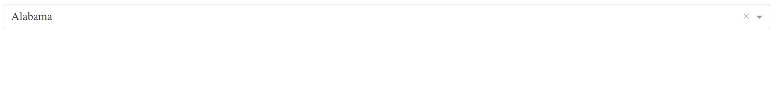

2. Above the dropdown, add an html.Div, and assign to the id property the string “my-title”. Add your own title to the children property of the html.Div. Below the dropdown, add an empty dcc.Graph. The id of the graph component should be “graph1”.

This is the result that you should see:

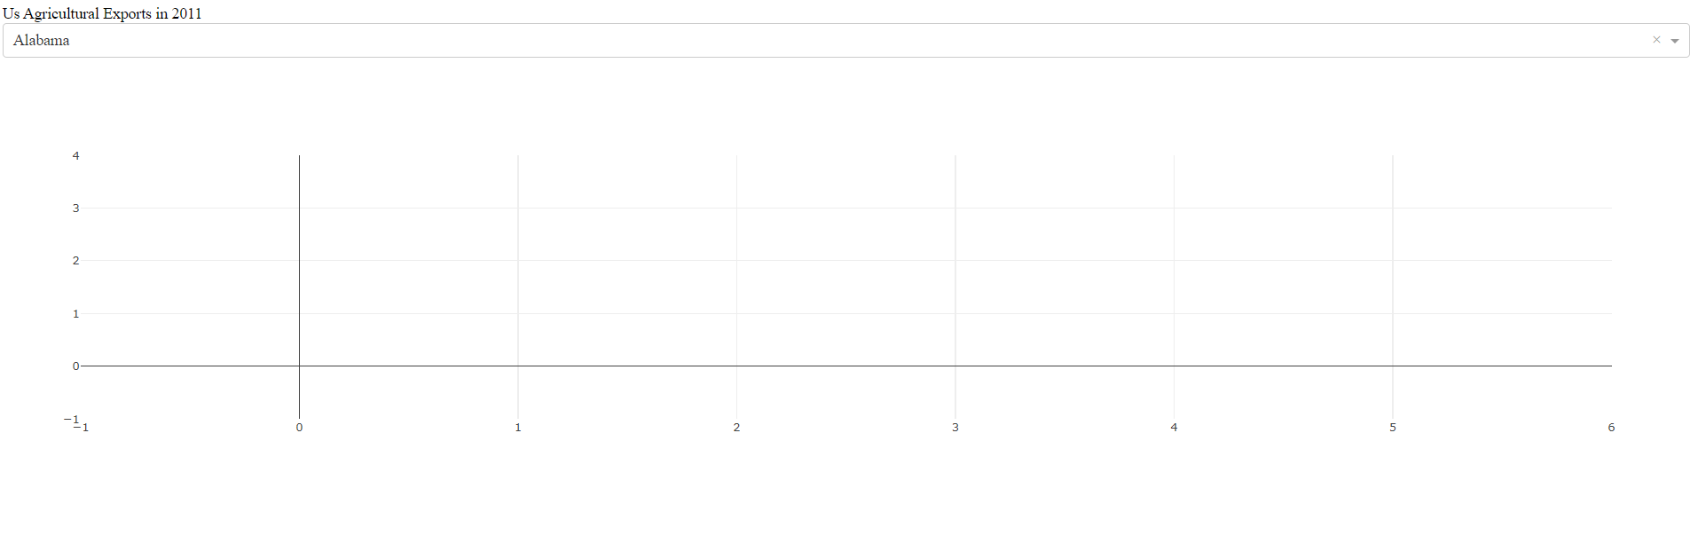

**Exercise B:** Add a [callback](https://dash.plotly.com/tutorial#controls-and-callbacks) to your app.

1. Add a callback decorator that takes the value of the dcc.Dropdown as an Input argument and the figure of the dcc.Graph as an Output argument. Remember to import the Input and Output arguments at the very top.

2. Add a callback function directly underneath the decorator. The function should take an argument called “state_selected”. Use pandas to filter the original dataframe (df) so that only rows with the “state_selected” remain in the new dataframe. Name the new dataframe “df_country”.

Create a [bar chart](https://plotly.com/python/bar-charts/#bar-charts-with-wide-format-data) with three arguments: the “df_country” assigned to the data_frame attribute; “state” assigned to the x-axis; and a list of three column names assigned to the y-axis. ['beef','pork','fruits fresh']

Return the bar chart at the end of the function. This is the app that you should see:

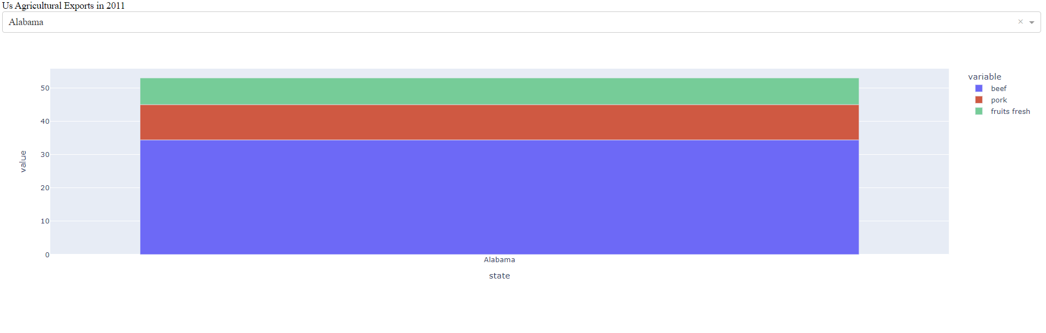

3. Let’s work with a [multi-value dropdown](https://dash.plotly.com/dash-core-components/dropdown#multi-value-dropdown). Use the multi property to allow your dropdown to accept multiple values. Update the value property by assigning it ["Alabama","Arkansas"]

Now that the dropdown value property is of type list, update the callback function: use pandas’ [isin method](https://pandas.pydata.org/pandas-docs/stable/reference/api/pandas.DataFrame.isin.html) on the state column to filter the dataframe according to the “states_selected”. The rest of the callback function can stay the same.

This is the app that you should see:

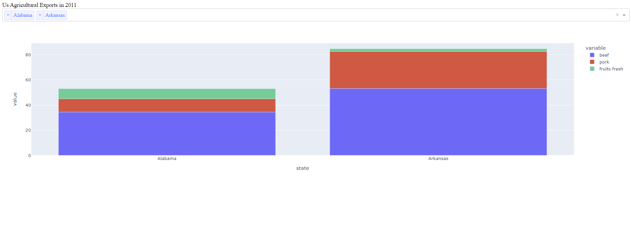

**Exercise C:** Choose your app project.

* We encourage you to think of an app that you would like to build by the end of this course. You can choose one of the two datasets ([agriculture](https://github.com/plotly/datasets/blob/master/Dash-Course/US-Exports/2011_us_ag_exports.csv), [makeup](https://github.com/plotly/datasets/blob/master/Dash-Course/makeup-shades/shades.csv)) provided in the course or your own dataset. When choosing a project, think of the following:
  + What data would I like to analyze? Is the data simple and clean?
  + What is the purpose of building this app?
  + What are you trying to facilitate or demonstrate with the app?
  + Why would you or others use your app?
* Post your thoughts on the forum if you want community feedback
* At the end of the course, when you’ve finished your Dash app, make sure to post the code and app images on the forum, under the [dash-online-course tag](https://community.plotly.com/tag/dash-online-course). If you can’t share your app publicly, feel free to message me on the forum or email it to me.
* Your final Dash App should be posted on the forum **by October 26**. If you’d like to present your app in the final live session, please submit your app **by October 23**.
* 5 to 6 participants will be selected to present their apps to Plotly staff members at the last session.